# 3. Software Requirement Specifications

## 3.1. User Requirement Specification

### 3.1.1. Guest Requirements

Guest is a person who does not have accessed to the system, but can use some functions in the system. In order to use more functions, guest must login to the website. There are some functions guest can use:

* Register
* Get Job Alert
* Find job
* View Company Detail
* View Job Information

### 3.1.2. Job Seeker Requirements

Jobseeker Seekers are guests who have successfully logged into system with their accounts. They can use additional functions, such as:

* Login
* Logout
* Get Job Alert
* Find Job
* View Company Detail
* View Job Information
* Manage Applied Job
* Manage Company Profile
* Manage Skill
* Apply Job
* Save job
* Manage Resume
* Manage Benefit

### 3.1.3. Recruiter Requirements

Recruiters are the people who represent for their companies to recruit staff. Recruiter account has to be active by manager. They can use the following functions:

* Login
* Logout
* Find Job Seeker
* Buy Job Package
* Buy advertise
* View Transaction
* Manage Company Profile
* Manage Job Posting
* Manage Applicant

### 3.1.4. Staff Requirements

* Login
* Logout
* Manage Common List
* Manage Topic

### 3.1.5. Manager Requirements

Manager is a person who manages the activities of website and takes care about the running services. Manage can use the following function:

* Login
* Logout
* View Statistic Report.
* Manage Job Package
* Manage Advertise Cost

### 3.1.6. Administrator Requirements

Admin is the person who manages the system Admin is super user who can use the following functions:

* Login
* Logout
* Manage Account.
* Manage Problem Report.
* Manage Advertise

### 3.1.7. Common function

The following functions are using by more than one role:

* Logout <Authorized User>
* Sending Report <Job Seeker, Recruiter, Manager>
* Manage Message <Authorized User>
* Manage Topic <Job Seeker, Recruiter, Manager>

## 3.2. System Requirement Specification

### 3.2.1. External Interface Requirements

#### 3.2.1.1. User Interfaces

* General requirement for graphics user interface is the GUI should be simple, clear, intuitive, and reminiscent.
* The interface design is an iterative process includes: design, sketching, prototyping, user assessment.

#### 3.2.1.2. Hardware Interfaces

N/A

#### 3.2.1.3. Software Interfaces

Job Searching System can run with multiple browsers such as:

* Firefox (33.1.0.5423)
* Chromes (version 39.0.2171.71)
* Cốc Cốc (version 35.0.1916.157)

And must support JavaScript and HTML5

#### 3.2.1.4. Communications Protocol

Using HTML/HTTPS protocol

### 3.2.2. Functional Requirements

This section will describe the system being built through a list of Use cases. First, we will have an over-view of the whole system and what it will do through a use case diagram. There’re 6 main actors: Guest, Jobseeker, Recruiter, Staff , Manager and Administrator.

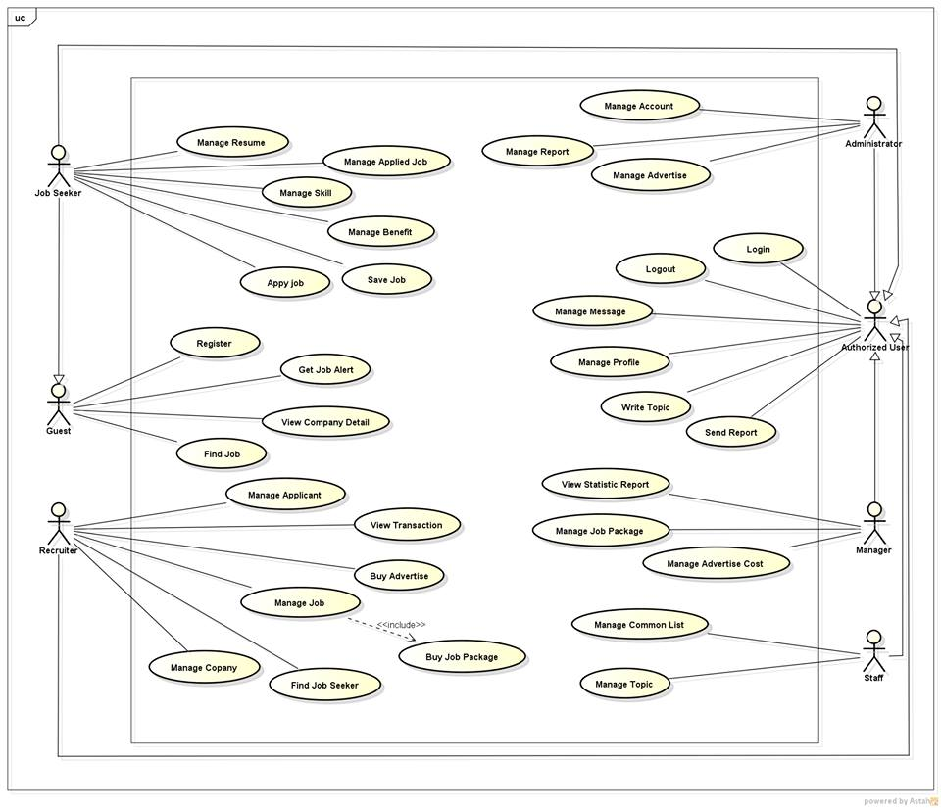

#### 3.2.2.1. <Guest> Overview Use Case

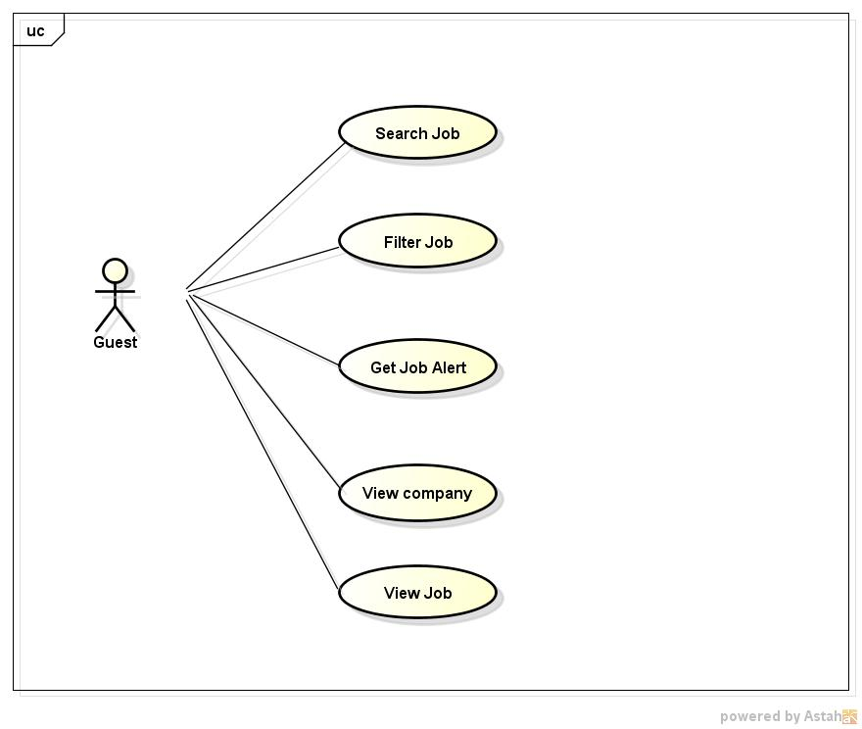

Figure 1: <Guest> Overview Use Case

##### 3.2.2.1.1. <Guest> Search Jobs

###### 3.2.2.1.2.1. Use case Diagram

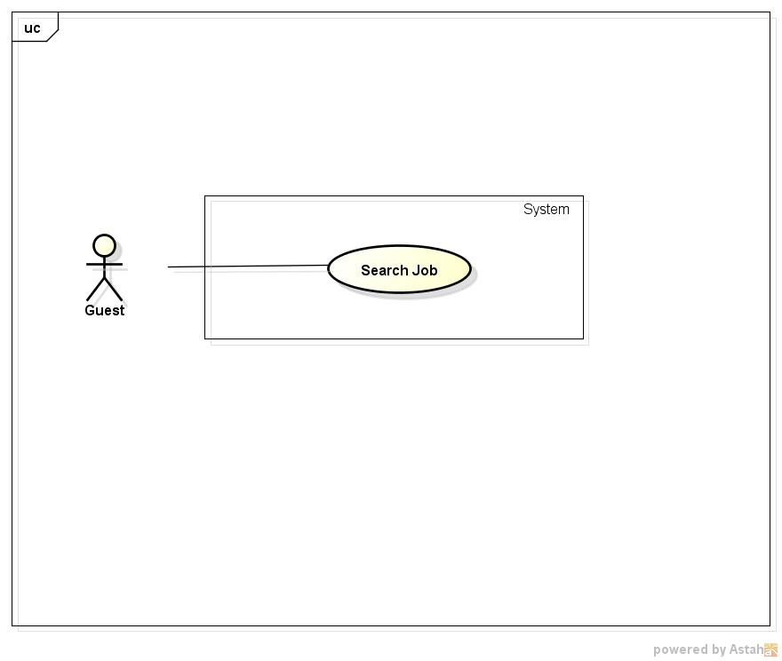

**Figure 2: <Guest> Search Jobs Use Case Diagram**

###### 3.2.2.1.2.1. Use case Specification

|  |  |  |  |
| --- | --- | --- | --- |
| **USE CASE –001** | | | |
| **Use Case No.** | 001 | **Use Case Version** | 1.0 |
| **Use Case Name** | Search Jobs | | |
| **Author** | Nguyen Ngoc Thien | | |
| **Date** | 18/05/2015 | **Priority** | High |
| **Actor:**   * Guest * Jobseeker * Recruiter * Manager * Administrator   **Summary:**   * User can make a quick search to find out information about jobs they concern by its name , by minimum salary, work location,etc right after entering to website   **Goal:**   * Search for jobs directly from home page   **Triggers:**   * Job Searching System homepage screen is displayed   **Preconditions:**   * Job Searching System homepage screen is displayed, the job name, minimum salary are entered and criterias such as expected work location , job categories are selected . Search button is clicked.   **Post Conditions:**   * Job Searching System display a list of job   **Main Success Scenario:**   |  |  |  | | --- | --- | --- | | Step | Actor Action | System Response | | 1 | Type job’s name, minimum salary into textbox , select school level , select expected work location select job category on Job Searching System homepage | Auto-complete feature will check and gives suggested list bases on characters that user input | | 2 | Click “Tìm kiếm” button | * Searching in database all of jobs that satisfy search key word and criterias * Display a list of jobs that suitable with those criteria or show message “Không có công việc nào thỏa tiêu chí của bạn” |   **Alternative Scenario:**  N/A  **Exceptions:**  N/A  **Relationships:**  N/A  **Business Rules:**  Only dislay jobs matching with search condition and have end date larger than current date | | | |

##### 3.2.2.1.5. <Guest> View Job

###### 3.2.2.1.5.1. Use case Diagram

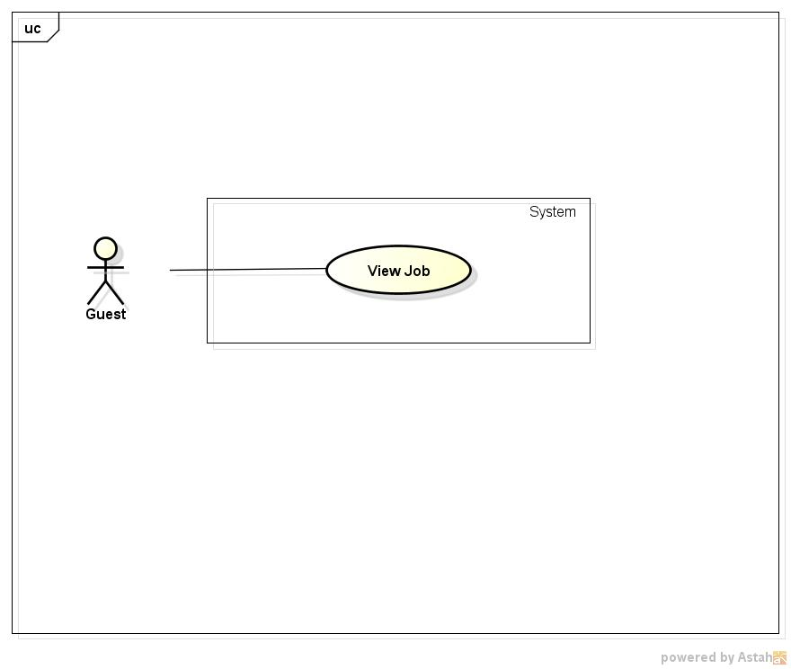

**Figure 6: <Guest> View Job Use Case Diagram**

###### 3.2.2.1.5.2. Use case Specification

|  |  |  |  |
| --- | --- | --- | --- |
| **USE CASE –005** | | | |
| **Use Case No.** | 005 | **Use Case Version** | 1.0 |
| **Use Case Name** | View Job | | |
| **Author** | Nguyen Ngoc Thien | | |
| **Date** | 18/05/2015 | **Priority** | High |
| **Actor:**   * Guest * Jobseeker * Recruiter * Manager * Administrator   **Summary:**   * When user click a job link, redirect to job’s information page   **Goal:**   * Display detailed information of clicked job   **Triggers:**   * Click job post link on homepage or search result page   **Preconditions:**   * Job Searching System homepage screen is displayed and has at least one job or on the job searching result page has at least one job   **Post Conditions:**   * Job Information page is displayed   **Main Success Scenario:**   |  |  |  | | --- | --- | --- | | Step | Actor Action | System Response | | 1 | Click on a job in home page or on job searching result page | Redirect to “Thông tin công việc” page contains:   * Job’s basic information block contains: * Job’s name * Company’s logo * Company’s info * Company’s location * Salary * “Nộp đơn” button * Job summary block contains: * Job level * Job category * Foreign language * Job’s benefit block contains: * A list of benefit * Job’s skill contains: * Essential skills are required for job * Job’s description block contains: * Description what this job is about and what job seeker will must do * Job requirement block contains: * Specific requirements for job such as experiment, attitude, etc |   **Alternative Scenario:**  N/A  **Exceptions:**   |  |  |  | | --- | --- | --- | | No | Actor Action | System Response | | 1 | Click on job in home page or on job searching result page which was deleted in database | Show error message “ Công việc này không tồn tại” | | 2 | Click on job in home page or on job searching result page which end date larger than now | Show error message “ Công việc này đã hết hạn hiển thị” |   **Relationships:**  N/A  **Business Rules:**  Users cannot see job if end date of job is larger than the time which user click job | | | |

#### 3.2.2.2. <Job Seekers> Overview Use Case

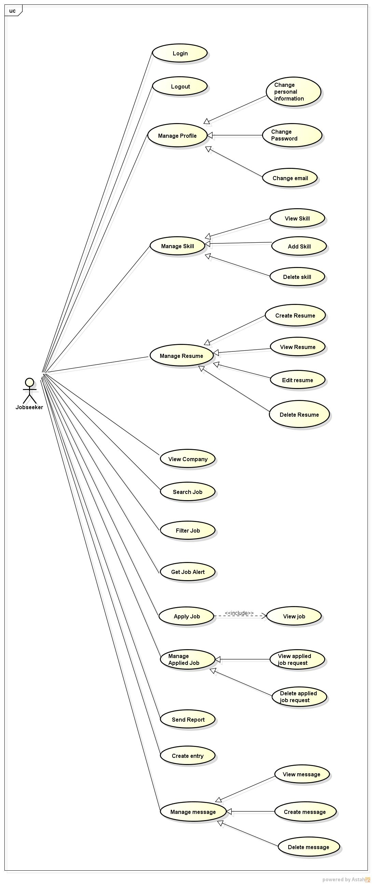

Figure 7: <Job Seekers> Overview Use Case

##### 3.2.2.2.13. <Job Seeker> Apply Job

###### 3.2.2.2.13.1. Use case Diagram

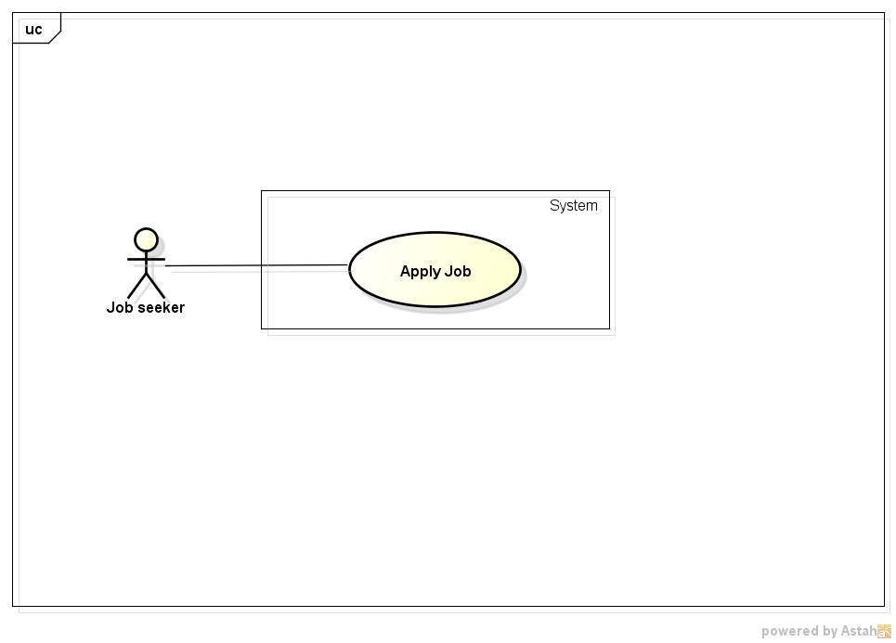

**Figure 20: <Job Seeker> Apply Job Use Case Diagram**

###### 3.2.2.2.13.2. Use case Specification

|  |  |  |  |
| --- | --- | --- | --- |
| **USE CASE –018** | | | |
| **Use Case No.** | 018 | **Use Case Version** | 1.0 |
| **Use Case Name** | Apply Job | | |
| **Author** | Nguyen Ngoc Thien | | |
| **Date** | 18/05/2015 | **Priority** | High |
| **Actor:**   * Job Seeker   **Summary:**   * This use case allow user to apply a job on Job Searching System   **Goal:**   * Allow job seeker send apply request to recruiter   **Triggers:**   * Click on a job post * In a job post click “Nộp đơn” button, “Nộp đơn” dialog is displayed * Then in “Nộp đơn” dialog click button “Gửi”   **Preconditions:**   * User login successfully with role Job Seeker * Have at least a job post on Job Searching System * Redirect successfully to a job post’s information page   **Post Conditions:**   * Apply request of job seeker is sent to recruiter   **Main Success Scenario:**   |  |  |  | | --- | --- | --- | | Step | Actor Action | System Response | | 1 | Select a job post in Job Searching System | Redirect to “Thông tin công việc” page | | 2 | Click “Nộp đơn” | Display a “Nộp đơn ”dialog contains:   * Overview information of jobseeker like: avatar, name, email, location, phone number * “Hồ sơ” radio button with options allow user choose Resumes which they created on Job Searching System * “Gửi” button * “Hủy” button | | 3 | Select “Gửi” button | - Sending apply job request to recruiter which contains informations in “Nộp đơn” dialog   * Display send applied request success dialog   - Dismiss “Nộp đơn” dialog |   **Alternative Scenario:**   |  |  |  | | --- | --- | --- | | No | Actor Action | System Response | | 1 | At step 3 click “Hủy” button instead of “Gửi” button | Dismiss “Nộp đơn” dialog |   **Exceptions:**  **N/A**  **Relationships:**   * Login * View job   **Business Rules:**   * A jobseeker cannot send many apply request for a job * Jobseeker cannot apply a job if they don’t have any resume | | | |

##### 3.2.2.2.14. <Job Seeker> View Applied Job Request

###### 3.2.2.2.14.1. Use case Diagram

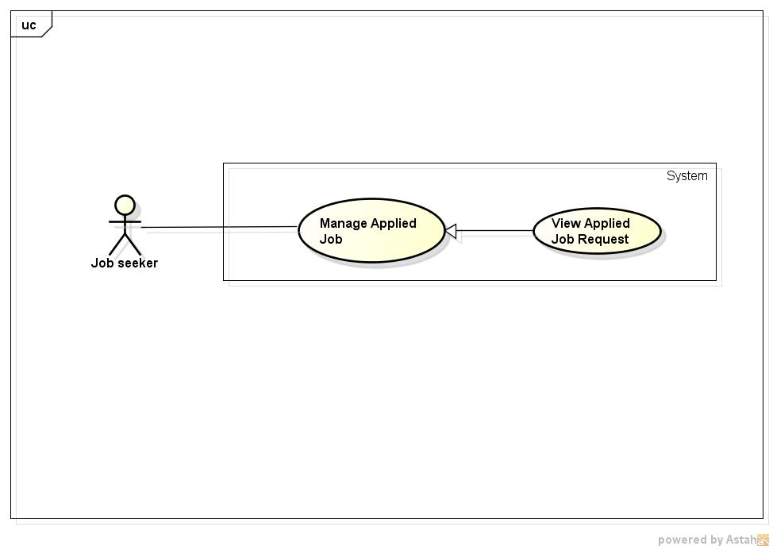

**Figure 21: <Job Seeker> View Applied Job request Use case Diagram**

###### 3.2.2.2.14.2. Use case Specification

|  |  |  |  |
| --- | --- | --- | --- |
| **USE CASE –019** | | | |
| **Use Case No.** | 019 | **Use Case Version** | 1.0 |
| **Use Case Name** | View Applied Job Request | | |
| **Author** | Nguyen Ngoc Thien | | |
| **Date** | 18/05/2015 | **Priority** | High |
| **Actor:**   * Job Seeker   **Summary:**   * This use case allow user to view applied job request   **Goal:**   * View applied job requests   **Triggers:**   * Click “Quản lý tình trạng ứng tuyển” item in drop down menu of job seeker   **Preconditions:**   * Login successfully with role Job seeker   **Post Conditions:**   * Display a list of applied job request or “Bạn hiện tại không ứng tuyển vào bất kì công việc nào” message   **Main Success Scenario:**   |  |  |  | | --- | --- | --- | | Step | Actor Action | System Response | | 1 | Click “Quản lý tình trạng ứng tuyển” item on drop down menu of job seeker | Redirect to “Quản lý tình trạng ứng tuyển” page contains :   * A table contains list of applied job request which each line contain job’s name, company’s name, applied date, response of recruiter and “Xóa” button |   **Alternative Scenario:**  **N/A**  **Exceptions:**  **N/A**  **Relationships:**   * Login   **Business Rules:**  **N/A** | | | |

##### 3.2.2.2.15. <Job Seeker> Delete Applied Job

###### 3.2.2.2.15.1. Use case Diagram

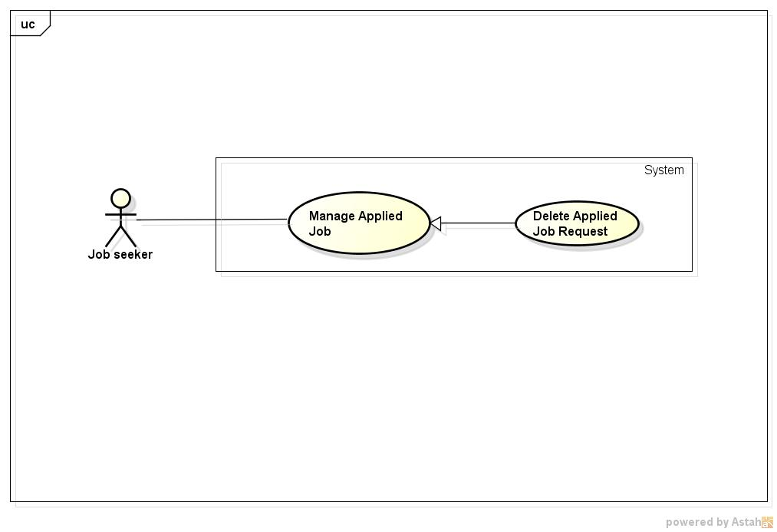

**Figure 22: <Job Seekers> Delete Applied Job Use Case Diagram**

###### 3.2.2.2.15.2. Use case Specification

|  |  |  |  |
| --- | --- | --- | --- |
| **USE CASE –020** | | | |
| **Use Case No.** | 020 | **Use Case Version** | 1.0 |
| **Use Case Name** | Delete Applied Job | | |
| **Author** | Nguyen Ngoc Thien | | |
| **Date** | 18/05/2015 | **Priority** | High |
| **Actor:**   * Job Seeker   **Summary:**   * This use case allow user to cancel a job request which is sent to recruiter   **Goal:**   * Delete a job request   **Triggers:**   * From drop down menu of jobseeker click on “Quản lý tình trạng ứng tuyển” item * Click “Xóa” link on same line with job that you want to cancel apply request   **Preconditions:**   * Job seeker have at least a job request   **Post Conditions:**   * Cancel a apply request to recruiter   **Main Success Scenario:**   |  |  |  | | --- | --- | --- | | Step | Actor Action | System Response | | 1 | Click “Quản lý tình trạng ứng tuyển” item on drop down menu of jobseeker | Redirect to “Quản lý tình trạng ứng tuyển” page contains a list of apply job requests | | 2 | Click “Xóa” link on same line with apply job request which want to delete | Delete applied job request in database and send message to inform about canceling applied job request of job seeker to recruiter |   **Alternative Scenario:**  N/A  **Exceptions:**  N/A  **Relationships:**   * Login   **Business Rules:**  N/A | | | |

##### 3.2.2.2.17. <Job Seeker> View Message

###### 3.2.2.2.17.1. Use case Diagram

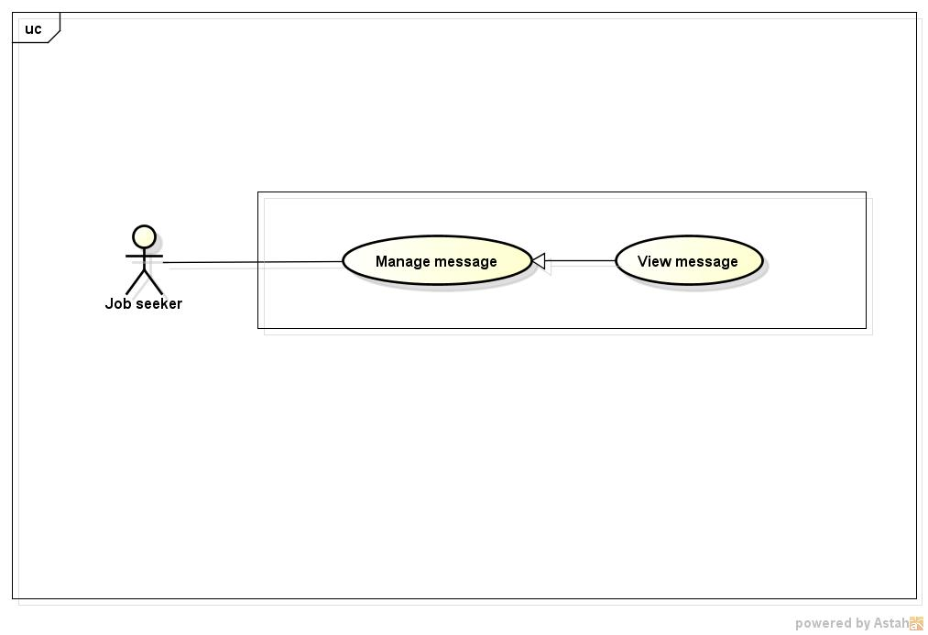

**Figure 24: <Job Seeker> View Message Use Case Diagram**

###### 3.2.2.2.17.2. Use case Specification

|  |  |  |  |
| --- | --- | --- | --- |
| **USE CASE –001** | | | |
| **Use Case No.** | 022 | **Use Case Version** | 1.0 |
| **Use Case Name** | View message | | |
| **Author** | Nguyen Ngoc Thien | | |
| **Date** | 18/05/2015 | **Priority** | High |
| **Actor:**   * Job Seeker * Recruiter * Manager * Administrator   **Summary:**   * This use case allow user see messages are sent from others   **Goal:**   * View messages   **Triggers:**   * Click “Tin nhắn” item in drop down menu of user   **Preconditions:**   * Login successfully   **Post Conditions:**   * Display a list of message or “Empty” message   **Main Success Scenario:**   |  |  |  | | --- | --- | --- | | Step | Actor Action | System Response | | 1 | Click “Tin nhắn” item on drop down menu of job seeker | Redirect to “Tin nhắn” page contains below items:   * List of message with checkbox in every item * “Tạo tin nhắn”button. * “Xóa tin nhắn” button | | 2 | Click on specific message want to read | Redirect to Message Content page display content of message |   **Alternative Scenario:**  N/A  **Exceptions:**  N/A  **Relationships:**   * Login   **Business Rules:**  N/A | | | |

##### 3.2.2.2.18. <Job Seeker> Create Message

###### 3.2.2.2.18.1. Use case Diagram

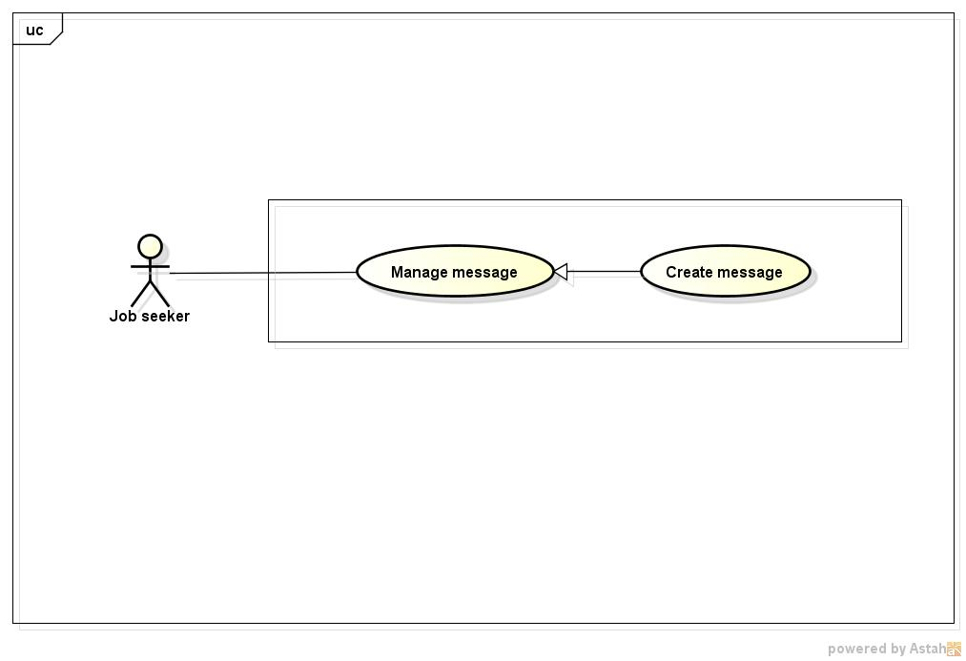

**Figure 25: <Job Seeker> Create Message Use Case Diagram**

###### 3.2.2.2.18.2. Use case Specification

|  |  |  |  |
| --- | --- | --- | --- |
| **USE CASE –023** | | | |
| **Use Case No.** | 023 | **Use Case Version** | 1.0 |
| **Use Case Name** | Create message | | |
| **Author** | Nguyen Ngoc Thien | | |
| **Date** | 18/05/2015 | **Priority** | High |
| **Actor:**   * Job Seeker * Recruiter * Manager * Administrator   **Summary:**   * This use case allow user create message and send to others   **Goal:**   * Send messages   **Triggers:**   * Click “Tin nhắn” item in drop down menu of user * Then click “Tạo tin nhắn ” button   **Preconditions:**   * Login successfully   **Post Conditions:**   * Send successfully a message to other   **Main Success Scenario:**   |  |  |  | | --- | --- | --- | | Step | Actor Action | System Response | | 1 | Click “Tin nhắn” item on drop down menu of job seeker | Redirect to “Tin nhắn” page contains below items:   * List of message with checkbox in every item * “Tạo tin nhắn”button. * “Xóa tin nhắn” button | | 2 | Click “Tạo tin nhắn” button | Display a dialog contains:   * “Người nhận” textbox, required * “Nội dung” text area, required, maxlength: 1000 * “Gửi” button * “Hủy” button | | 3 | Input receiver’s name on “Người nhận” textbox | Auto suggest name of users contain characters of user input | | 4 | Input content on “Nội dung” text area and click button “Gửi” | Send message to receivers |   **Alternative Scenario:**   |  |  |  | | --- | --- | --- | | No | Actor Action | System Response | | 1 | At step 3 click “Hủy” button instead of “Gửi” button | Dismiss dialog |   **Exceptions:**   |  |  |  | | --- | --- | --- | | No | Actor Action | System Response | | 1 | Leave empty on “Người nhận” text box | When leave focus out of textbox auto show error message “Vui lòng điền người nhận” beside “Người nhận” text box | | 2 | Leave empty on “Nội dung” text area | When leave focus out of textbox auto show error message “Vui lòng nhập nội dung” on bottom of “Nội dung” text area |   **Relationships:**   * Login   **Business Rules:**   * A user can send message for many user involve themselves | | | |

##### 3.2.2.2.19. <Job Seeker> Delete message

###### 3.2.2.2.19.1. Use case Diagram

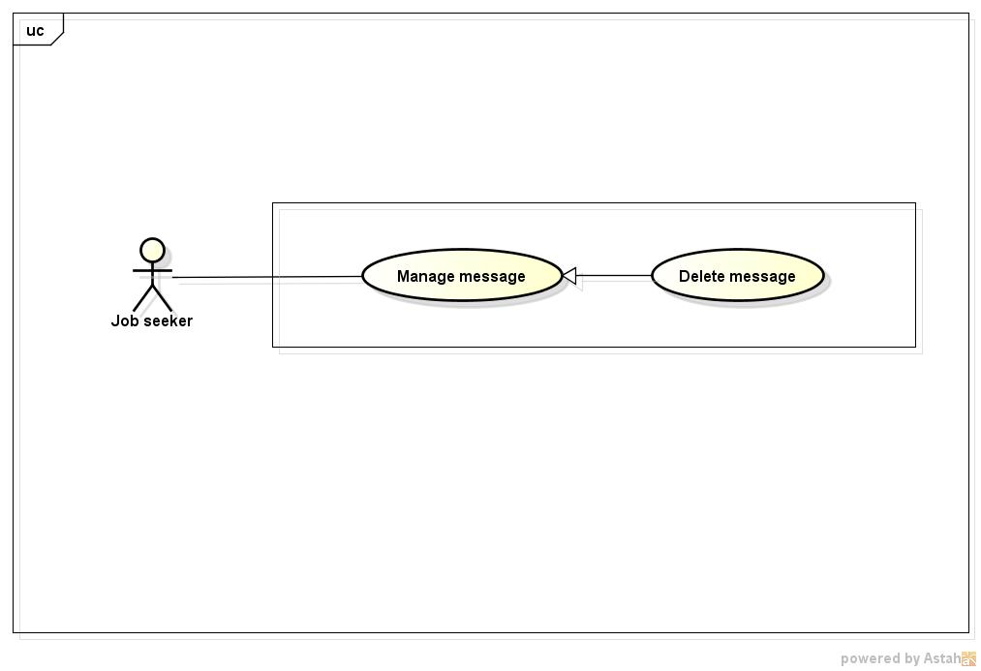

**Figure 26: <Job Seeker> Search Jobs Use Case Diagram**

###### 3.2.2.2.19.2. Use case Specification

|  |  |  |  |
| --- | --- | --- | --- |
| **USE CASE –024** | | | |
| **Use Case No.** | 024 | **Use Case Version** | 1.0 |
| **Use Case Name** | Delete message | | |
| **Author** | Nguyen Ngoc Thien | | |
| **Date** | 18/05/2015 | **Priority** | High |
| **Actor:**   * Job Seeker * Recruiter * Manager * Administrator   **Summary:**   * This use case allow user delete messages   **Goal:**   * Delete messages   **Triggers:**   * Click “Tin nhắn” item in drop down menu of user * Tick on checkbox on message which want to delete then click “Xóa tin nhắn” button   **Preconditions:**   * Login successfully   **Post Conditions:**   * Delete successfully messages   **Main Success Scenario:**   |  |  |  | | --- | --- | --- | | Step | Actor Action | System Response | | 1 | Click “Tin nhắn” item on drop down menu of job seeker | Redirect to “Tin nhắn” page contains below items:   * List of message with checkbox in every item * “Tạo tin nhắn”button. * “Xóa tin nhắn” button | | 2 | Tick on checkboxes which want to delete , then click button “Xóa tin nhắn” | Display a delete confirm dialog contains:   * “Bạn có muốn xóa những tin nhắn này?” text * “Có” button * “Không” button | | 3 | Click “Có” button | Delete those messages in database and refresh list of message |   **Alternative Scenario:**   |  |  |  | | --- | --- | --- | | No | Actor Action | System Response | | 1 | At step 3 click “Hủy” button instead of “Gửi” button | Dismiss dialog |   **Exceptions:**   |  |  |  | | --- | --- | --- | | 1 | Delete a message that already is deleted | Display a dialog “Tin nhắn này đã được xóa” |   **Relationships:**   * Login   **Business Rules:**  N/A | | | |

#### 3.2.2.3. <Recruiter> Overview Use Case

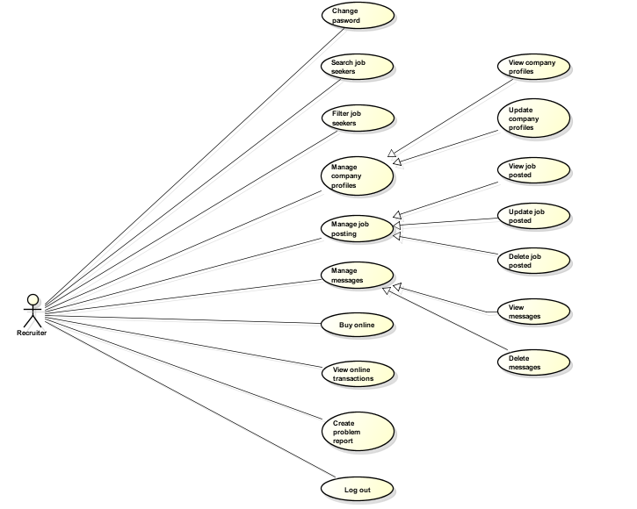

Figure 27: <Recuiters> Overview Use Case

##### 3.2.2.3.8. <Recruiter> Buy Advertise

###### 3.2.2.3.8.1. Use case Diagram

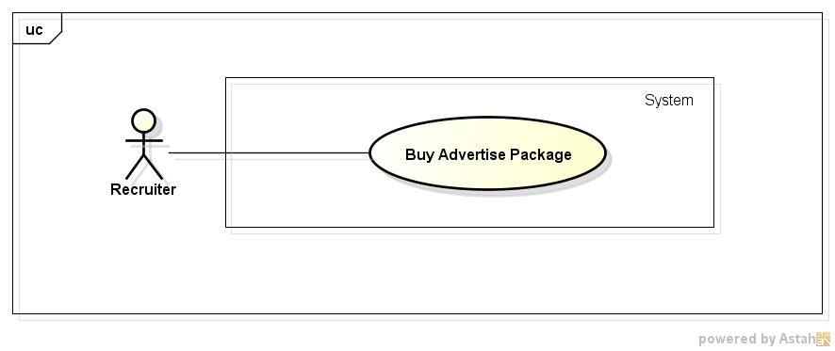

**Figure 35: <Recuiter> Buy Online Use Case Diagram**

###### 3.2.2.3.8.2. Use case Specification

|  |  |  |  |
| --- | --- | --- | --- |
| **USE CASE –014** | | | |
| **Use Case No.** | 032 | **Use Case Version** | 1.0 |
| **Use Case Name** | Buy Advertise Package | | |
| **Author** | Nguyen Ngoc Thien | | |
| **Date** | 18/05/2015 | **Priority** | High |
| **Actor:**   * Recruiter   **Summary:**   * In this case, recruiters can buy advertise package   **Goal:**   * Recruiter can buy advertise package   **Triggers:**   * Recruiter click on “Mua quảng cáo” item on drop down menu of recruiter   **Preconditions:**   * Recruiter has already logged in   **Post Conditions:**   * Send advertise package request to manager   **Main Success Scenario:**   |  |  |  | | --- | --- | --- | | Step | Actor Action | System Response | | 1 | Recruiter click on “Mua quảng cáo” item on drop down menu of recruiter | Redirect to Advertise Package page contains types of advertise package with “Mua” button in each type of package | | 2 | Recruiter click button “Mua” below any advertise package | Redirect to Invoice page contains:   * Web’s information blocks: * Name of web ( Job Searching System) * Phone * Address of office * Information of banking account * Logo upload block contains: * Image block * “Tải lên” button * Invoice information block contains: * Name of advertise package * Price * Position of advertise which will be displayed on website’s home page * “Gửi yêu cầu” button and “Hủy” button | | 3 | Recruiter click button “Tải lên” | Display a window browser dialog to choose logo image | | 4 | Choose image and click “Tải lên” button | Upload that image and load image into Image block | | 5 | Click “Gửi yêu cầu” button | Send Advertise Request Package to Staff and display dialog “Bạn đã gửi yêu cầu mua quảng cáo thành công” | | 6 | Click “Đóng” button on dialog | Redirect to Advertise Package page |   **Alternative Scenario:**   |  |  |  | | --- | --- | --- | | Step | Actor Action | System Response | | 1 | Click Hủy button | Redirect to Advertise Package page |   **Exceptions:**   |  |  |  | | --- | --- | --- | | Step | Actor Action | System Response | | 1 | Don’t upload logo and click “Gửi yêu cầu” button | Display warning dialog “Quý công ty vui lòng chọn logo sẽ được hiển thị trên trang web của chúng tôi” | | 2 | Select a not image file to upload | Display error dialog “Upload thất bại” | | 3 | Click “Gửi” button but connection to database is down | Display error dialog “Gửi yêu cầu mua gói coong việc thất bại ” |   **Relationships:**   * Login use case   **Business Rules:**   * Recruiter can buy many advertise package | | | |

##### 3.2.2.3.8. <Recruiter> Buy Job Package

###### 3.2.2.3.8.1. Use case Diagram

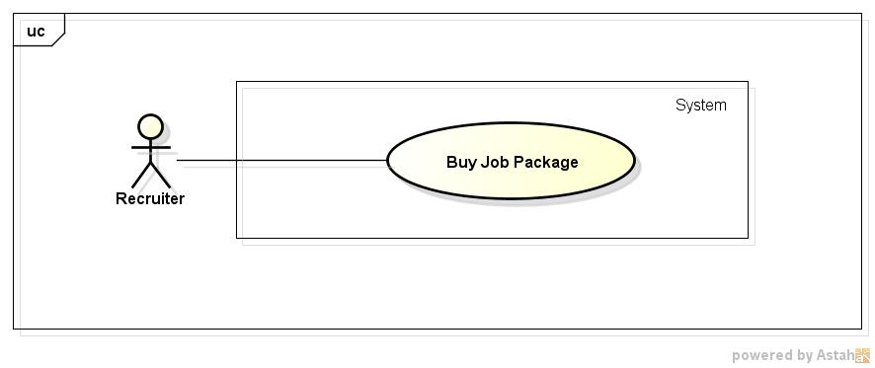

**Figure 35: <Recuiter> Buy Job Package**

###### 3.2.2.3.8.2. Use case Specification

|  |  |  |  |
| --- | --- | --- | --- |
| **USE CASE –014** | | | |
| **Use Case No.** | 032 | **Use Case Version** | 1.0 |
| **Use Case Name** | Buy Job Package | | |
| **Author** | Nguyen Ngoc Thien | | |
| **Date** | 18/05/2015 | **Priority** | High |
| **Actor:**   * Recruiter   **Summary:**   * In this case, recruiters can buy job package   **Goal:**   * Recruiter can buy job package   **Triggers:**   * Recruiter click on “Mua gói công việc” item on drop down menu of recruiter   **Preconditions:**   * Recruiter has already logged in   **Post Conditions:**   * Send job package request to manager   **Main Success Scenario:**   |  |  |  | | --- | --- | --- | | Step | Actor Action | System Response | | 1 | Recruiter click on “Mua gói công việc” item on drop down menu of recruiter | Redirect to Job Package page contains types of job package with “Mua” button in each type of package | | 2 | Recruiter click button “Mua” below any job package | Redirect to Invoice page contains:   * Web’s information blocks: * Name of web ( Job Searching System) * Phone * Address of office * Information of banking account * Invoice information block contains: * Name of job package * Price * Quantity of job package * “Gửi yêu cầu” button and “Hủy” button | | 3 | Click “Gửi yêu cầu” button | Send Job Package Request to Manager and display dialog “Bạn đã gửi yêu cầu mua gói công việc thành công” | | 4 | Click “Đóng” button on dialog | Redirect to Job Package page |   **Alternative Scenario:**   |  |  |  | | --- | --- | --- | | Step | Actor Action | System Response | | 1 | Click Hủy buttoc | Redirect to Job Package page |   **Exceptions:**   |  |  |  | | --- | --- | --- | | Step | Actor Action | System Response | | 1 | Click “Gửi” button but connection to database is down | Display error dialog “Gửi yêu cầu mua gói coong việc thất bại ” |   **Relationships:**   * Login use case   **Business Rules:**   * Recruiter can buy many job package | | | |

##### 3.2.2.3.10. <Recruiter> Create Problem Reports

###### 3.2.2.3.10.1. Use case Diagram

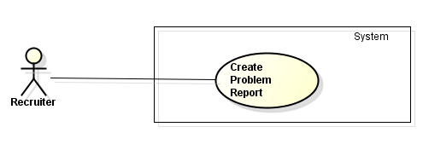

**Figure 37: <Recuiter> Create Problem Reports Use Case Diagram**

###### 3.2.2.3.10.2. Use case Specification

|  |  |  |  |
| --- | --- | --- | --- |
| **USE CASE –034** | | | |
| **Use Case No.** | 034 | **Use Case Version** | 1.0 |
| **Use Case Name** | Create Problem Report | | |
| **Author** | Nguyen Ngoc Thien | | |
| **Date** | 18/05/2015 | **Priority** | High |
| **Actor:**   * Jobseeker * Recruiter   **Summary:**   * In this case, user can create problem reports to send to staff   **Goal:**   * User can create problem reports to send to Admin   **Triggers:**   * Click “Báo cáo” button on Job Detail page or on Topic Detail page   **Preconditions:**   * Recruiter and Jobseeker have already logged in   **Post Conditions:**   * Send report success to Admin   **Main Success Scenario:**   |  |  |  | | --- | --- | --- | | Step | Actor Action | System Response | | 1 | Click on “Báo cáo” button | Report modal is displayed contains:   * Text area, max length:1000 * “Gửi” button and “Hủy” button | | 2 | Input content in text area and click “Gửi” button | Send report to Admin and display success dialog “ Bạn đã gửi báo cáo thành công” | | 3 | Click “Đóng” button | Dismiss report modal |   **Alternative Scenario:**   |  |  |  | | --- | --- | --- | | Step | Actor Action | System Response | | 1 | Recruiter click on “Hủy” button | Dismiss report modal |   **Exceptions:**   |  |  |  | | --- | --- | --- | | Step | Actor Action | System Response | | 1 | Don’t enter report’s content to text area and click “Gửi” button | Display a alert “Vui lòng nhập nội dung báo cáo” | | 2 | Enter to text area more than 1000 characters and click “Gửi” button | Display error message “Nội dung báo cáo không được vượt quá 1000 ký tự” |   **Relationships:**   * Login use case   **Business Rules:**  N/A | | | |

#### 3.2.2.4. <Administrator> Overview Use Case

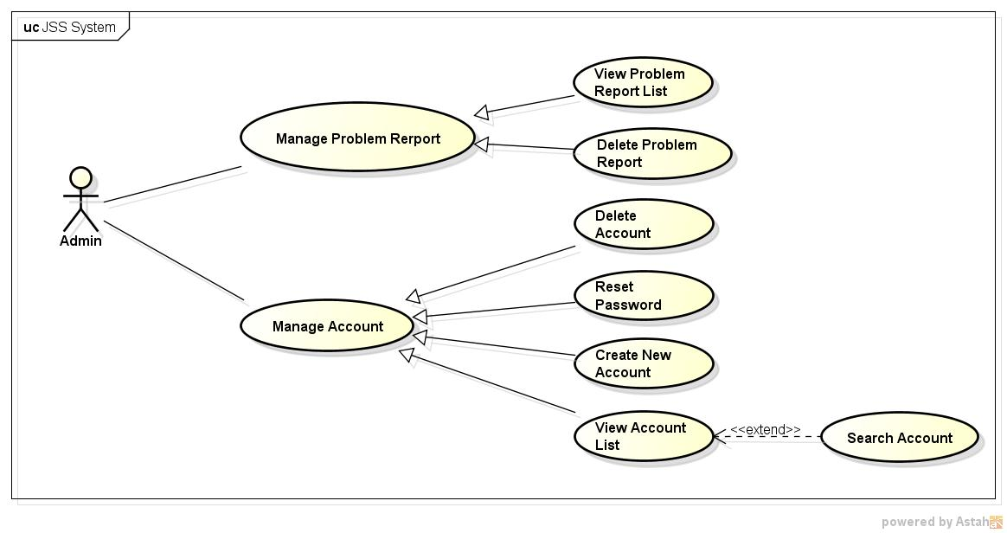

Figure 38: <Administrator> Overview Use Case

##### 3.2.2.4.1. < Administrator> View Account List and Search Account

###### 3.2.2.4.1.1. Use case Diagram

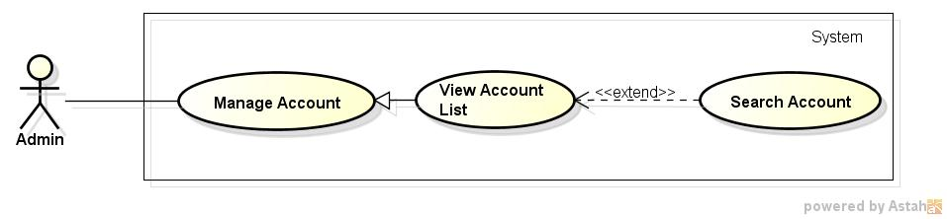

**Figure 39: <Administrator> View Account List and Search Account Use case Diagram**

###### 3.2.2.4.1.2. Use case Specification

|  |  |  |  |
| --- | --- | --- | --- |
| **USE CASE –035** | | | |
| **Use Case No.** | 035 | **Use Case Version** | 1.0 |
| **Use Case Name** | View Account List and Search Account | | |
| **Author** | Pham Quoc Thai | | |
| **Date** | 20/05/2015 | **Priority** | High |
| **Actor:**   * Administrator.   **Summary:**  In this case, admin can view account list and search account.  **Goal:**  All account display successfully.  **Triggers:**  Click on tab "Danh sách tài khoản" on Admin Home Page.  **Preconditions:**  Admin must login into website.  **Post Conditions:**  N/A  **Main Success Scenario:**   |  |  |  | | --- | --- | --- | | Step | Actor Action | System Response | | 1 | Click on tab " Danh sách tài khoản " on Admin home page. | All accounts display successfully. | | 2 | Input to Search textbox | System will show all accounts into list which their information contains the input keyword. |   **Alternative Scenario:**  N/A  **Exceptions:**  N/A  **Relationships:**  N/A  **Business Rules:**  N/A | | | |

***3.2.2.5. <Manager> Overview Use Case***

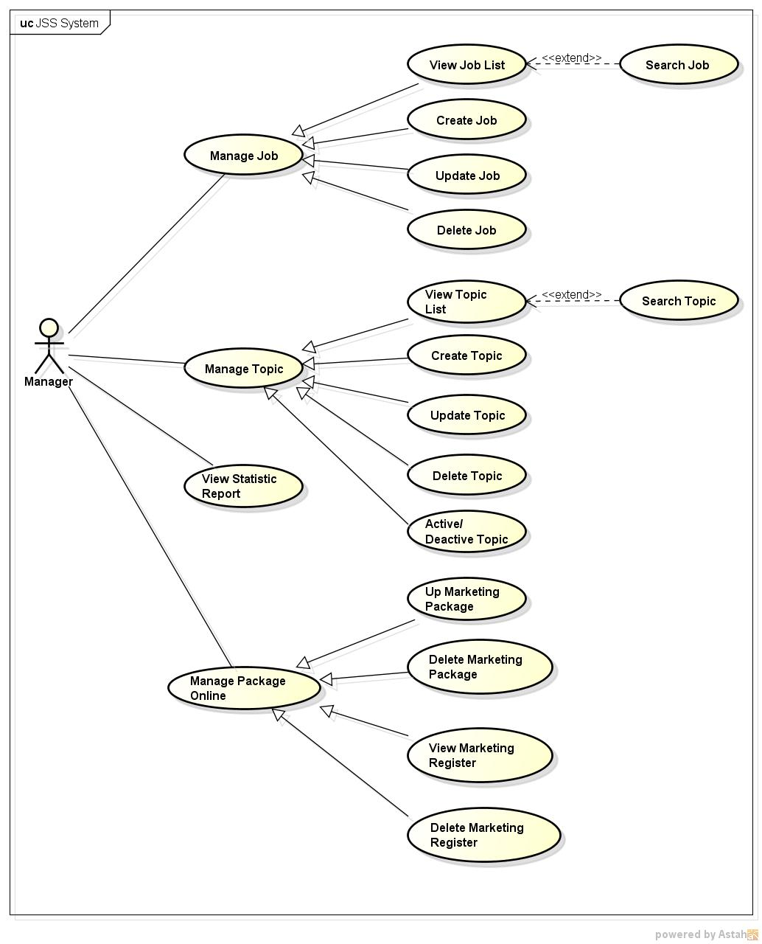

**Figure 45: <Manager> Overview Use Case**

3.2.2.5.1. < Manager> Approve Job Package Request

*3.2.2.5.1.1. Use case Diagram*

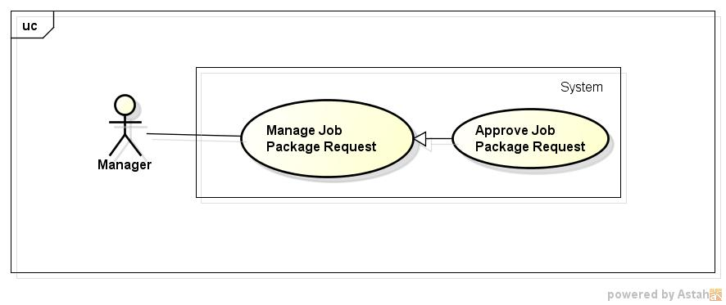

**Figure 46: <Manager> Approve Job Package Request Use case Diagram**

*3.2.2.5.1.2. Use case Specification*

|  |  |  |  |
| --- | --- | --- | --- |
| **USE CASE –040** | | | |
| **Use Case No.** | 040 | **Use Case Version** | 1.0 |
| **Use Case Name** | Approve Job Package Request | | |
| **Author** | Nguyen Ngoc Thien | | |
| **Date** | 20/05/2015 | **Priority** | High |
| **Actor:**   * Manager.   **Summary:**   * In this case, manager can approve job package request from recruiter.   **Goal:**   * Aprove job package request successfully   **Triggers:**   * Click on item “Quản lý yêu cầu mua gói công việc” on dropdown menu of manager.   **Preconditions:**   * Login successfully with role Manager   **Post Conditions:**   * Job package requests are approved   **Main Success Scenario:**   |  |  |  | | --- | --- | --- | | Step | Actor Action | System Response | | 1 | Click on item "Quản lý yêu cầu mua gói công việc" on dropdown menu of manager. | Redirect to “Quản lý yêu cầu mua gói công việc” page contains:   * “Chấp nhận nhiều” button and “Từ chối nhiều” button * Search textbox and “Tìm kiếm” button * A list of job package request .Each line has checkbox, recruiter’s username, job package name, quantity, “Chấp nhận” button, “Từ Chối” button | | 2 | Check on checkboxes in which want to approve then click “Chấp nhận nhiều” button | Searh in database those job package request and changes status to approve, then reload page |   **Alternative Scenario:**   |  |  |  | | --- | --- | --- | | Step | Actor Action | System Response | | 1 | Click “Chấp nhận” button on every line of record which want to approve | Approve that job package requests |   **Exceptions:**   |  |  |  | | --- | --- | --- | | Step | Actor Action | System Response | | 1 | Don’t tick any checkboxes click “Chấp nhận” button | Display alert “Vui lòng chọn các yêu cầu mua gói công việc bạn muốn chấp nhạn” |   **Relationships:**   * Login use case   **Business Rules:**   * Manager only approve when recruiter transfer enough money for those request | | | |

3.2.2.5.1. < Manager> Reject Job Package Request

*3.2.2.5.1.1. Use case Diagram*

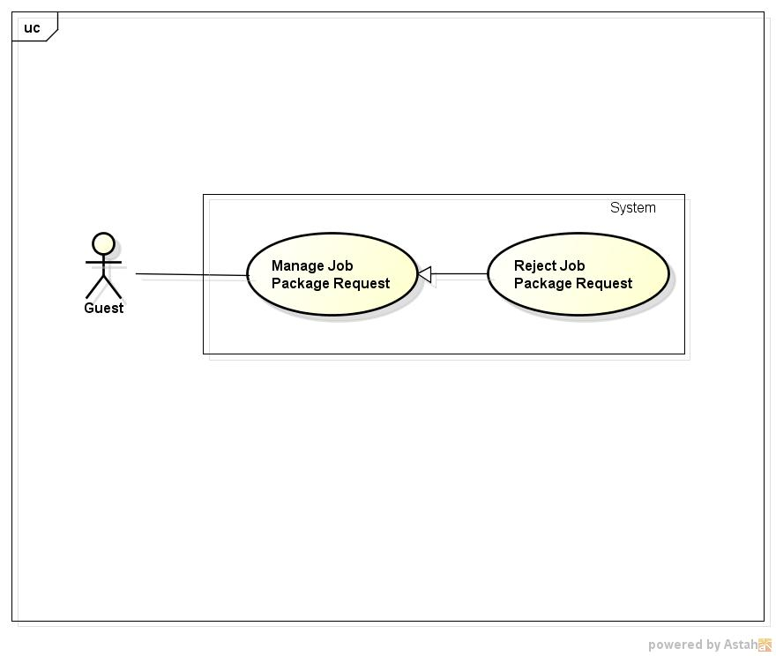

**Figure 46: <Manager> Reject Job Package Request Use case Diagram**

*3.2.2.5.1.2. Use case Specification*

|  |  |  |  |
| --- | --- | --- | --- |
| **USE CASE –040** | | | |
| **Use Case No.** | 040 | **Use Case Version** | 1.0 |
| **Use Case Name** | Reject Job Package Request | | |
| **Author** | Nguyen Ngoc Thien | | |
| **Date** | 20/05/2015 | **Priority** | High |
| **Actor:**   * Manager.   **Summary:**   * In this case, manager can reject job package request from recruiter.   **Goal:**   * Reject job package request successfully   **Triggers:**   * Click on item “Quản lý yêu cầu mua gói công việc” on dropdown menu of manager.   **Preconditions:**   * Login successfully with role Manager   **Post Conditions:**   * Job package requests are rejected   **Main Success Scenario:**   |  |  |  | | --- | --- | --- | | Step | Actor Action | System Response | | 1 | Click on item "Quản lý yêu cầu mua gói công việc" on dropdown menu of manager. | Redirect to “Quản lý yêu cầu mua gói công việc” page contains:   * “Chấp nhận nhiều” button and “Từ chối nhiều” button * Search textbox and “Tìm kiếm” button * A list of job package request .Each line has checkbox, recruiter’s username, job package name, quantity, “Chấp nhận” button, “Từ Chối” button | | 2 | Check on checkboxes in which want to reject then click “Từ chối nhiều” button | Searh in database those job package request and changes status to reject, then reload page |   **Alternative Scenario:**   |  |  |  | | --- | --- | --- | | Step | Actor Action | System Response | | 1 | Click “Từ Chối” button on every line of record which want to reject | Reject that job package requests |   **Exceptions:**   |  |  |  | | --- | --- | --- | | Step | Actor Action | System Response | | 1 | Don’t tick any checkboxes click “Từ chối” button | Display alert “Vui lòng chọn các yêu cầu mua gói công việc bạn muốn từ chối” |   **Relationships:**   * Login use case   **Business Rules:**   * Manager only reject when recruiter don’t transfer enough money for those job package request after 30 days | | | |

3.2.2.5.1. < Manager> Approve Advertise Package Request

*3.2.2.5.1.1. Use case Diagram*

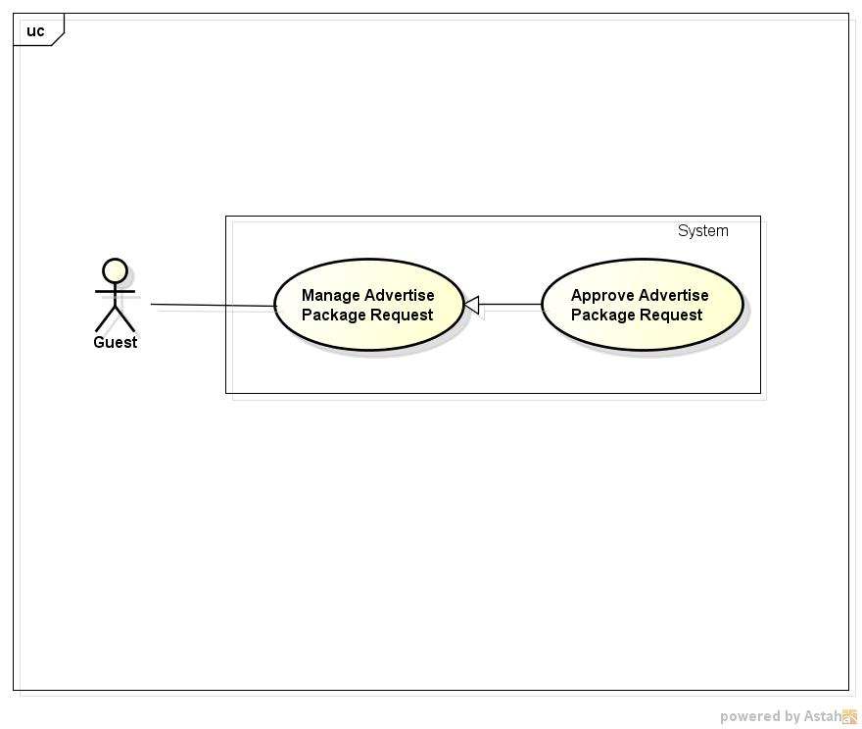

**Figure 46: <Manager> Approve Advertíse Package Request Use case Diagram**

*3.2.2.5.1.2. Use case Specification*

|  |  |  |  |
| --- | --- | --- | --- |
| **USE CASE –040** | | | |
| **Use Case No.** | 040 | **Use Case Version** | 1.0 |
| **Use Case Name** | Approve Adveriise Package Request | | |
| **Author** | Nguyen Ngoc Thien | | |
| **Date** | 20/05/2015 | **Priority** | High |
| **Actor:**   * Manager.   **Summary:**   * In this case, manager can approve advertise package request from recruiter.   **Goal:**   * Aprove advertise package request successfully   **Triggers:**   * Click on item “Quản lý yêu cầu mua gói quảng cáo” on dropdown menu of manager.   **Preconditions:**   * Login successfully with role Manager   **Post Conditions:**   * Job advertise requests are approved   **Main Success Scenario:**   |  |  |  | | --- | --- | --- | | Step | Actor Action | System Response | | 1 | Click on item "Quản lý yêu cầu mua gói quảng cáo" on dropdown menu of manager. | Redirect to “Quản lý yêu cầu mua gói quảng cáo” page contains:   * “Chấp nhận nhiều” button and “Từ chối nhiều” button * Search textbox and “Tìm kiếm” button * A list of advertise package request .Each line has checkbox, recruiter’s username, advertise package name, quantity, “Chấp nhận” button, “Từ Chối” button | | 2 | Check on checkboxes in which want to approve then click “Chấp nhận nhiều” button | Searh in database those advertise package request and changes status to approve, then reload page |   **Alternative Scenario:**   |  |  |  | | --- | --- | --- | | Step | Actor Action | System Response | | 1 | Click “Chấp nhận” button on every line of record which want to approve | Approve that advertise package requests |   **Exceptions:**   |  |  |  | | --- | --- | --- | | Step | Actor Action | System Response | | 1 | Don’t tick any checkboxes click “Chấp nhận” button | Display alert “Vui lòng chọn các yêu cầu mua gói quảng cáo bạn muốn chấp nhạn” |   **Relationships:**   * Login use case   **Business Rules:**   * Manager only approve when recruiter transfer enough money for those request | | | |

3.2.2.5.1. < Manager> Reject Advertise Package Request

*3.2.2.5.1.1. Use case Diagram*

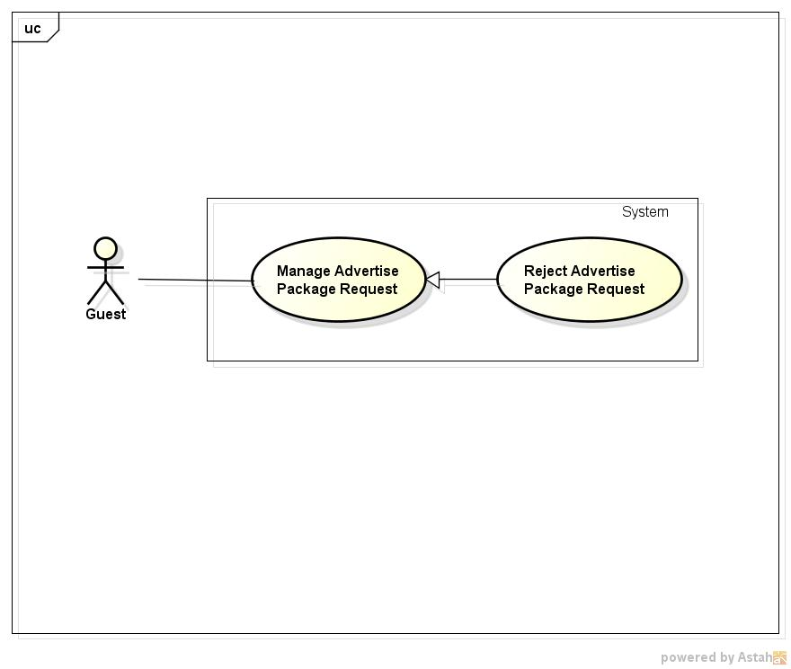

**Figure 46: <Manager> Reject Advertise Package Request Use case Diagram**

*3.2.2.5.1.2. Use case Specification*

|  |  |  |  |
| --- | --- | --- | --- |
| **USE CASE –040** | | | |
| **Use Case No.** | 040 | **Use Case Version** | 1.0 |
| **Use Case Name** | Reject Advertise Package Request | | |
| **Author** | Nguyen Ngoc Thien | | |
| **Date** | 20/05/2015 | **Priority** | High |
| **Actor:**   * Manager.   **Summary:**   * In this case, manager can reject advertise package request from recruiter.   **Goal:**   * Reject advertise package request successfully.   **Triggers:**   * Click on item “Quản lý yêu cầu mua gói quảng cáo” on dropdown menu of manager.   **Preconditions:**   * Login successfully with role Manager   **Post Conditions:**   * Job package requests are rejected   **Main Success Scenario:**   |  |  |  | | --- | --- | --- | | Step | Actor Action | System Response | | 1 | Click on item "Quản lý yêu cầu mua gói quảng cáo" on dropdown menu of manager. | Redirect to “Quản lý yêu cầu mua gói quảng cáo” page contains:   * “Chấp nhận nhiều” button and “Từ chối nhiều” button * Search textbox and “Tìm kiếm” button * A list of job package request .Each line has checkbox, recruiter’s username, advertise package name, quantity, “Chấp nhận” button, “Từ Chối” button | | 2 | Check on checkboxes in which want to reject then click “Từ chối nhiều” button | Searh in database those advertise package request and changes status to reject, then reload page |   **Alternative Scenario:**   |  |  |  | | --- | --- | --- | | Step | Actor Action | System Response | | 1 | Click “Từ Chối” button on every line of record which want to reject | Reject that advertise package requests |   **Exceptions:**   |  |  |  | | --- | --- | --- | | Step | Actor Action | System Response | | 1 | Don’t tick any checkboxes click “Chấp nhận” button | Display alert “Vui lòng chọn các yêu cầu mua gói quảng cáo bạn muốn từ chối” |   **Relationships:**   * Login use case   **Business Rules:**   * Manager only reject when recruiter don’t transfer enough money for that advertise package request after 30 days | | | |

### 3.2.3. Non-Functional Requirements

#### 3.2.3.1. Reliability

* All the transactions are managed by manager.
* System can perform roll back transaction when errors occurring.

#### 3.2.3.1. Availability

* The system can only run with network connection.
* All the functions can be used every time exclude maintenance time.

#### 3.2.3.1. Security

* Allow user to update account information and change their account password.
* Registry or changing email must require verification.
* The system automatically asks user to change their password every three months.
* All passwords are encrypted.
* Each role of user has a specific permission to interact with system.
* System always checks authorization and authentication before doing anything.

#### 3.2.3.1. Maintainability

* The system is easy to updated or modified, required maintenance time at most 8 hours.
* Data will be backed up once every two weeks.

#### 3.2.3.1. Portability

* The system could be moved to another platform like Android or IOS with 50% module of modules that need changing, with 6 people per 2 months and a half.

#### 3.2.3.1. Performance

## 3.3. Entity Relationship Diagram or Data Structure

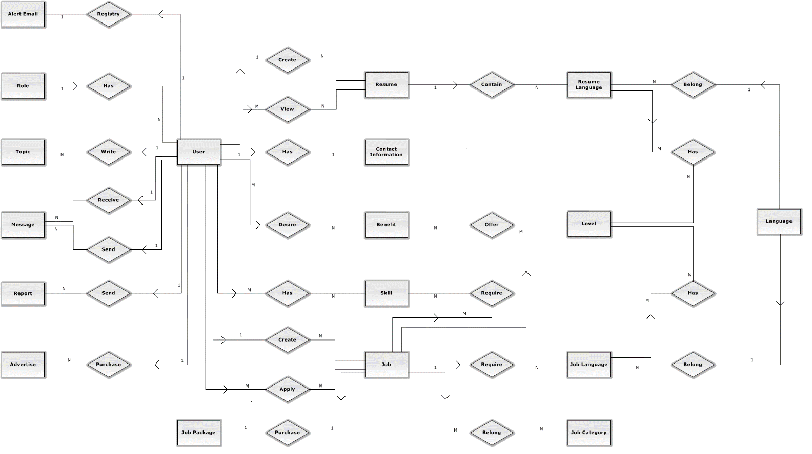

**Figure 50: Entity Relationship Diagram**

## 3.4. Entity Detail

